***The Unfavorable Economics of Measuring the Returns to Advertising***

Randall A. Lewis, Justin M. Rao

Summary by Benjamin Levine, Yegor Tkachenko

12/08/2017

* A lot of money is spent on advertising, but surprisingly little is known about how effective it is.
* Why?
  + Endogeneity
  + Statistical power
* These guys have unique **data** – 25 individual-level randomized control trials (RCTs) for digital ads, with individual-level tracking of post-exposure activity
  + Retailers (19) – tracking of in-store and online sales (dv)
  + Financial companies (6) – opening of a new account (dv)
* Paper is about measuring ad ROI
  + c – cost per user of the campaign
    - determines amount of impressions
  + – effect on sales
  + m – gross margin (revenue minus cost of goods sold removed)
  + – gross profit per person
  + – ROI
  + -100% - no effect
  + 0% - break even
* Key argument is that ROI of 25% is considered substantial, but it translates into very small effect size relative to the general variance in the dependent variable, and so the sample size has to be incredibly large to pick up this very weak signal in the noise – often beyond what advertisers can afford.
* Quantitative argument



is the avg. effect size, is the dummy for exposure to the ad. We assume equal variance in exposed and unexposed groups. Then, using the following equations, we can calculate partial R2, conditioning on other covariates.

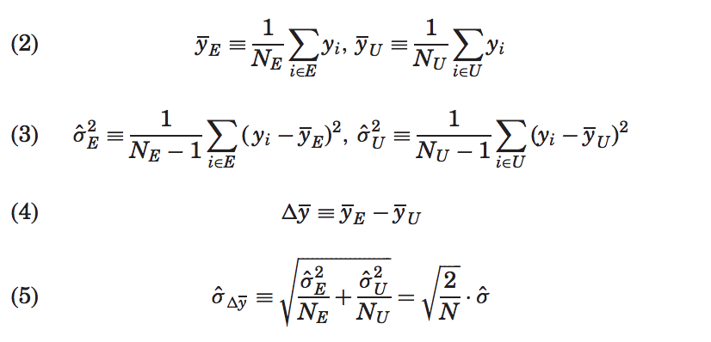

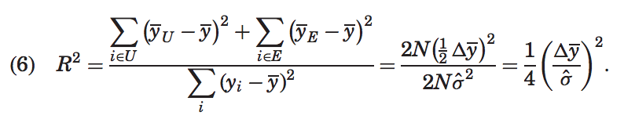

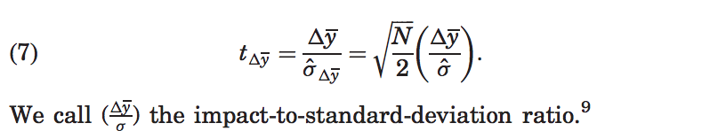

Also known as Cohen’s d.

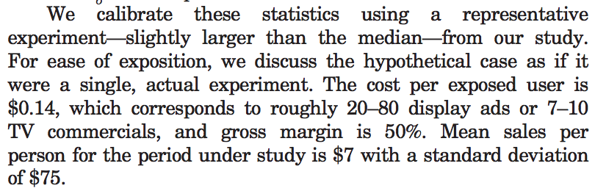

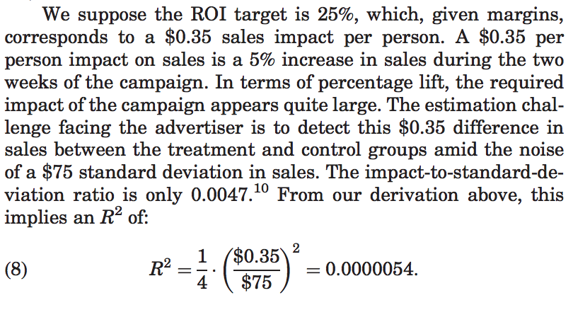

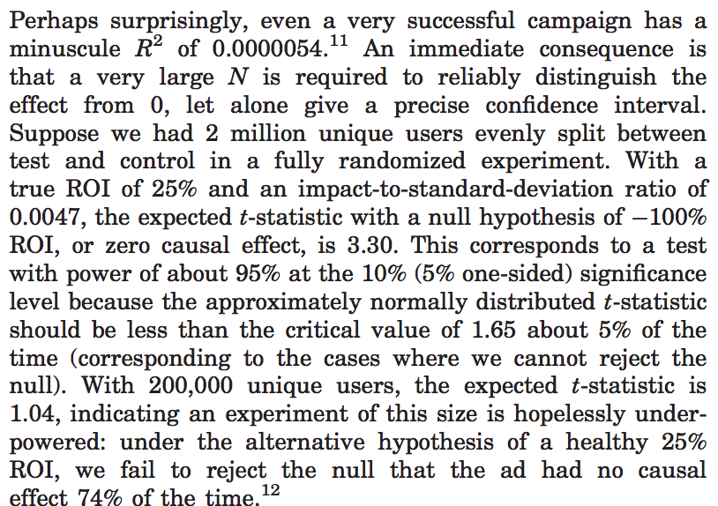

* Moreover, it means that observational studies are usually crap – smallest amount of endogeneity is enough to completely overwhelm and bias the true signal.
  + E.g., it is known that R2 due to intertemporal correlation between web browsing (ad exposure) and shopping is around 0.0001 – this is magnitude larger than R2 above – enough to totally bias the estimate
    - Basically, we see too much content in our lives to have an accurate estimate of the causal impact of seeing any one ad specifically
* Other problems
  + Error terms on coefficients are large – median confidence interval is about 100%
  + Larger per-person spend campaigns easier to measure, as are campaigns with lower sales variance
    - Even still, distinguishing 50% from 0% ROI is typically not possible with a $100,000 experiment involving millions of indiviudals

